Adam VonRuden Report

Top Drivers by Miles

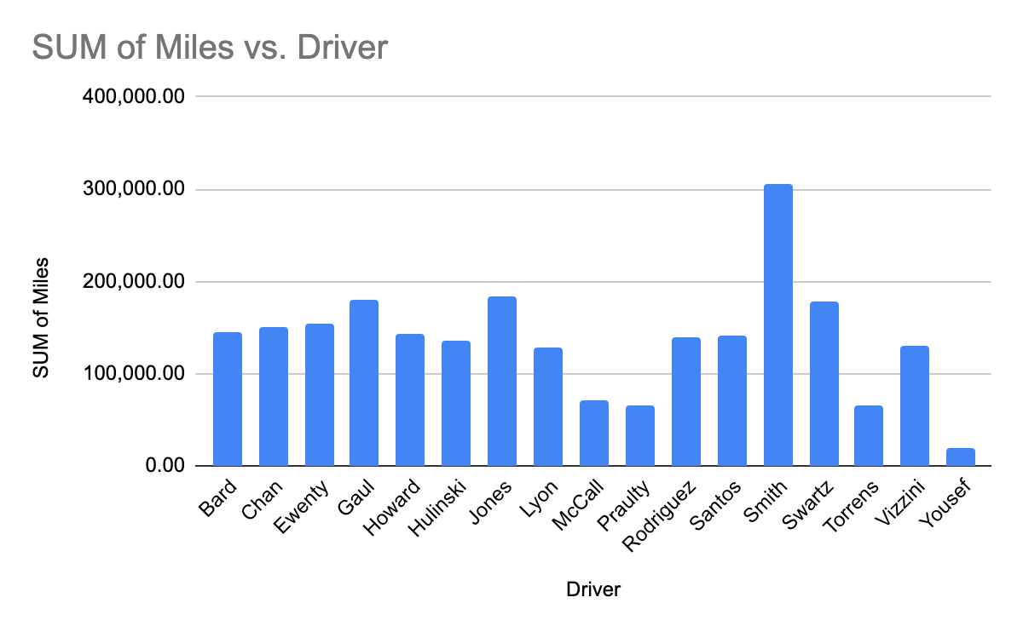

Scatter Chart for the Car Inventory. Miles on each car

